City Arts (Nottingham)

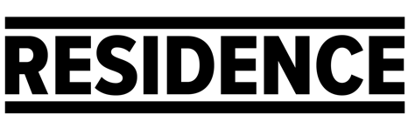
D/deaf, disabled or neurodivergent artists Bursary Proposal

Complete the form below to share your proposal.
Email it to recruitment@city-arts.org.uk.

About you
Full Name
Address
Postcode
Phone Number
Email Address

What is your previous experience of making art?
Max. 200 words
What kind of work do you make? Have you worked on any projects before?

What do you want to do with the bursary?
Max. 300 words
Describe your idea for a project and how you imagine it would work.

What do you want to get out of this opportunity?
Max. 200 words
How do you think it will help you develop as an artist and move your career forwards?

How will you spend your project budget?

Tips for pricing your project:
City Arts day rates for artists range from £100 - 200 per day. This depends on the project and the artist's previous experience. Think about your project and how much time you think you will need to achieve it, and what you could do for the £1200 fee offered.

Please share some examples of you work:
Paste images or links into this box

Deadline
The deadline for proposals is 6pm, 28 March 2022.

