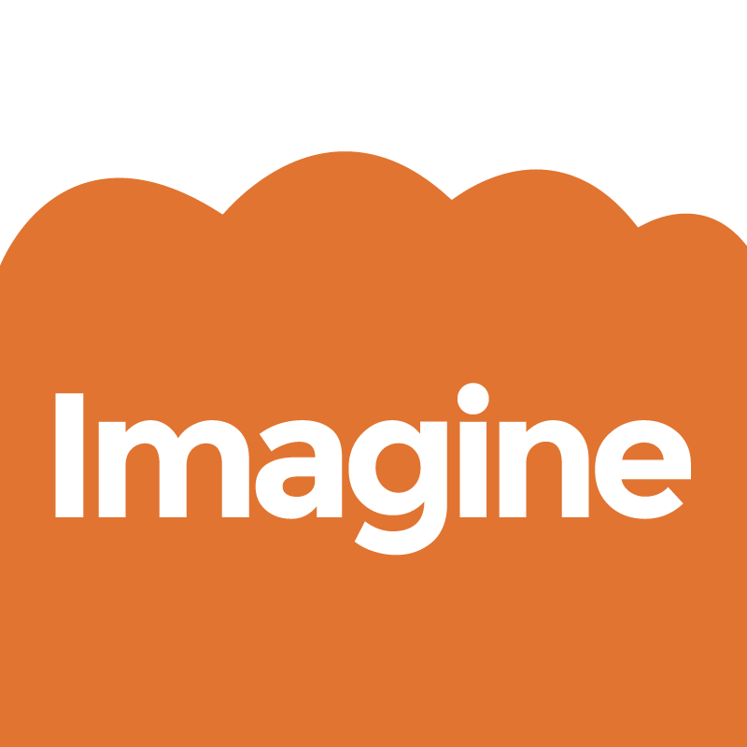 Call out for Freelance artists
Imagine: Arts and Older People Programme at Nottinghamshire Hospice
Background
Nottinghamshire Hospice is a partner in the national Arts and Older People in Care programme, which is a 3-year project funded by the Arts Council and Baring Foundation. In Nottingham this is a partnership programme between the Abbeyfields Society, City Arts, Nottingham City Council and Nottingham University.
For more information go to: www.city-arts.org.uk
Nottingham’s ‘Imagine’ programme is seeking a professional artist to come and engage our patient group with creative arts sessions leading to commissioned work, with inspiration coming from our newly landscaped garden.
Nottinghamshire Hospice is situated in beautiful grounds that have been recently renovated to improve patient access. With over 90 patients in total, we are a Day Therapy unit for up to 30 patients per day with palliative care needs. Average ages of patients are between 60 – 90 years. A Creative Art Therapist Co-ordinator supervises daily teams of volunteers and leads a programme of activities for patient enjoyment. The large clinical team support patients throughout their day. Please refer to our website and Facebook pages for a breadth of information about our service and setting www.nottshospice.org and www.facebook.com/NottinghamshireHospice
The Commission
We seek a professional artist who can work with and engage our patients, whilst being sensitive to individual needs and interests. You will plan and lead a series of short creative sessions with patients, supported by volunteers and the Creative Art Therapist Co-ordinator. Following this you will make and install a piece of creative work that will be situated in the garden for all to enjoy. We have an open mind as to what you might produce, but the participation and consultation with patients should be key in shaping your ideas. The final piece of work created should also be able to withstand outdoor conditions for a long period of time for people to enjoy.
Timescale and Budget
We anticipate this project being completed by the end of September 2014
The overall budget for this project is £1000
0.5 x Day: £85; 1 x Day: £175

The project will include:
1 x 0.5 Day: advance planning and preparation
5 x 0.5 Days: creative sessions with patients - during one week
2 x Days: Create and install commissioned work
Materials budget: £140 maximum
To apply please send:
- A proposal outlining the project (no more than 1 A4 page)
- Up to 3 images of your work
- CV with contact details and two referees (no more than 4 pages)

Deadline for applications 27th August at 5pm

Please submit entries to Andrea Grealy; Creative Art Therapist Co-ordinator
Nottinghamshire Hospice
384 Woodborough Road
Nottingham
NG3 4JF
email:
andreagrealy@nottshospice.org

